LS Code: Gives RBC velocity, Flux, and HCT values

Data Organization:

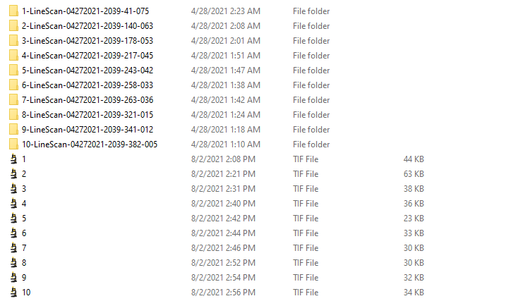example of data from one session: Put Raw LS data and selected images (1 frame out of 5 frames) in a folder. Raw LS data folder is used for extract calibration using function CF factor (frame period and micron per pixel)

Raw LS data folder name example: 1-LineScan-04272021-2039-41-075 (1 is the sequence number corresponds to tiff image name, second last number 41 is the depth)

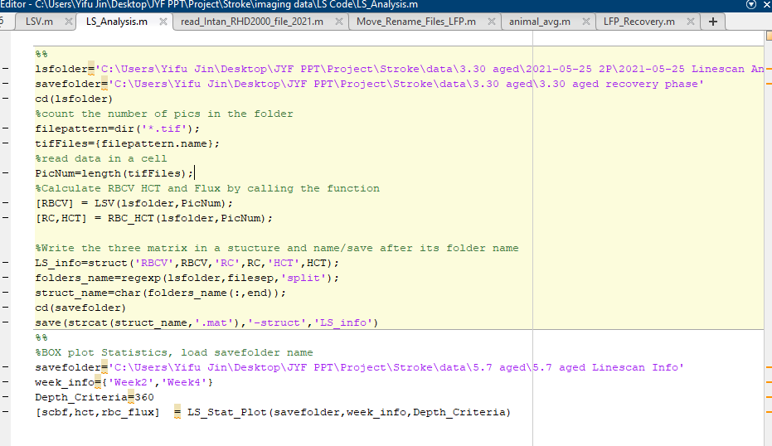

Main Code: Run LS_Analysis the highlighted part, lsfolder is the folder just organized, save folder is the folder to save the output: date_LS_info including RBCV, Flux and HCT values for each capillary

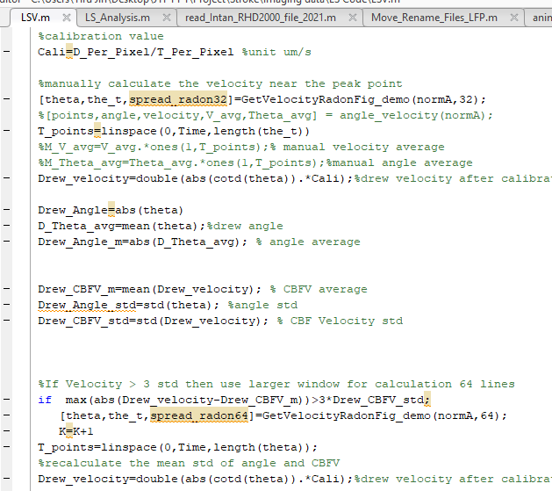

Called Functions:

LSV: compute the RBC Velocity,

If the image quality is bad and could not pass the noise rejection criteria, raw image will pop up and you will need to manually select two point on the lines to compute RBCV, click in direction left then right, left then right…

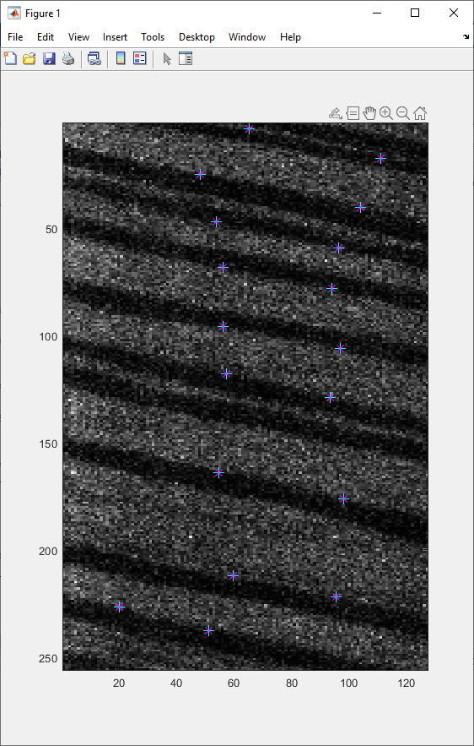

Example of points selection on lines for RBC velocity calculation

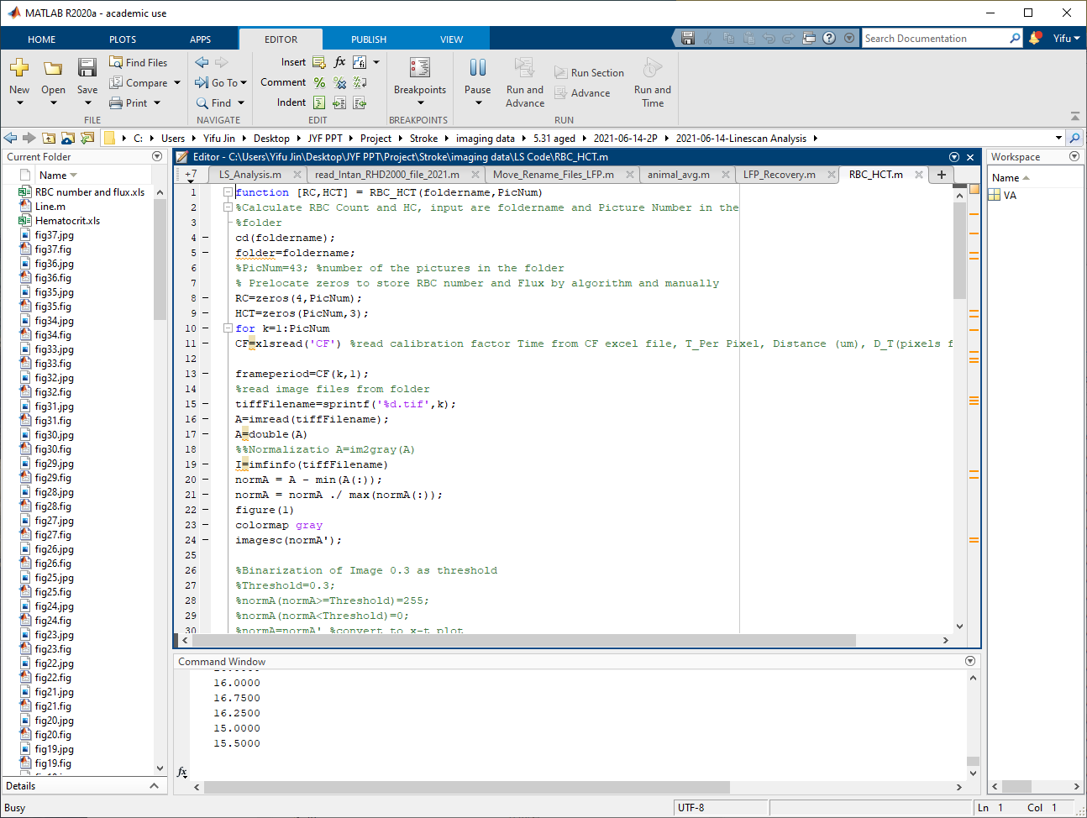

RBC_HCT computes RBC Counts in one frame to calculate Flux and HCT values of this frame

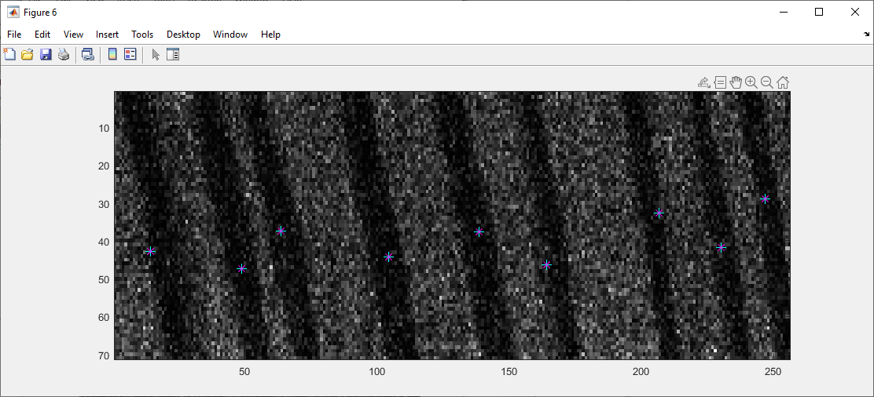

To calculate flux, on the pop out window, select stripes by clicking once on each stripe(count the stripes number). To calculate HCT, frames are binarized and dark pixels number are calculated over all pixels number(still update this algorithm, working with Yingchu on better segmentation methods; improving imaging quality is also important)